**Manuel of user (Use Case to Monitor the activity)**

1. To consult the list of the operations on vehicles at present in the deposit(warehouse), by prioritized status, it is necessary to go to the tab " to Consult the operations " (As on the screen shot below):

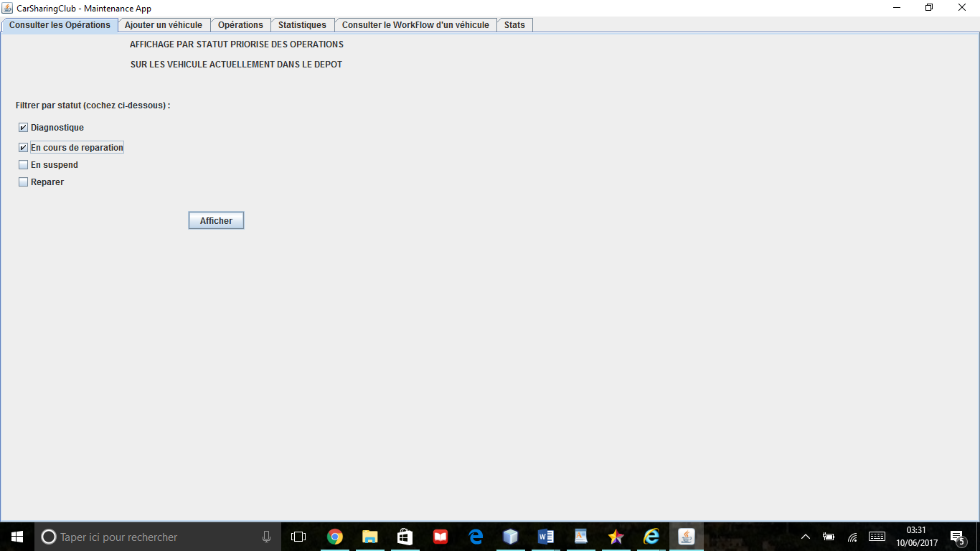

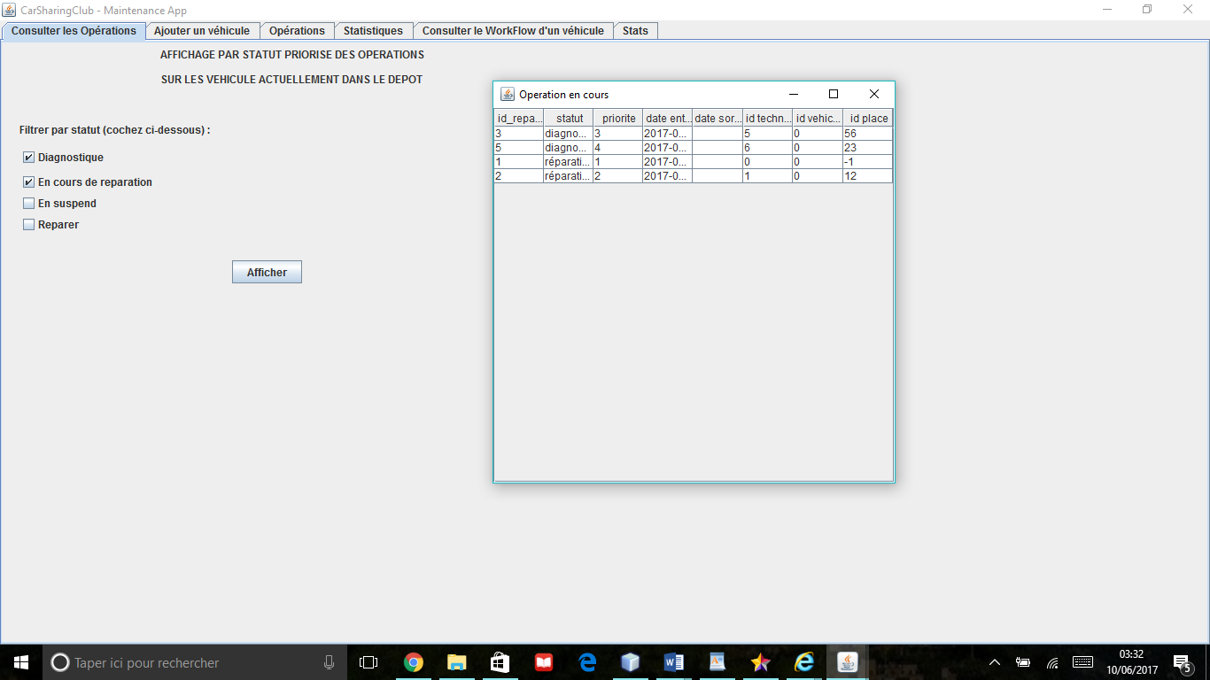

Then, choose the statuses (by checking boxes) for which you wish to show the list of the operations tidied up in an order of priority growing in groups of status. Then press the button "Afficher", you will then see a new page opening (see example above).  
To show all the operations on everything vehicles at present in the deposit, it is enough to you to select 4 statuses.

2) To show the detail of a vehicle that is its complete Workflow, it is necessary to go to the tab "to Consult the Workflow of a Vehicle" (See screen shot below):

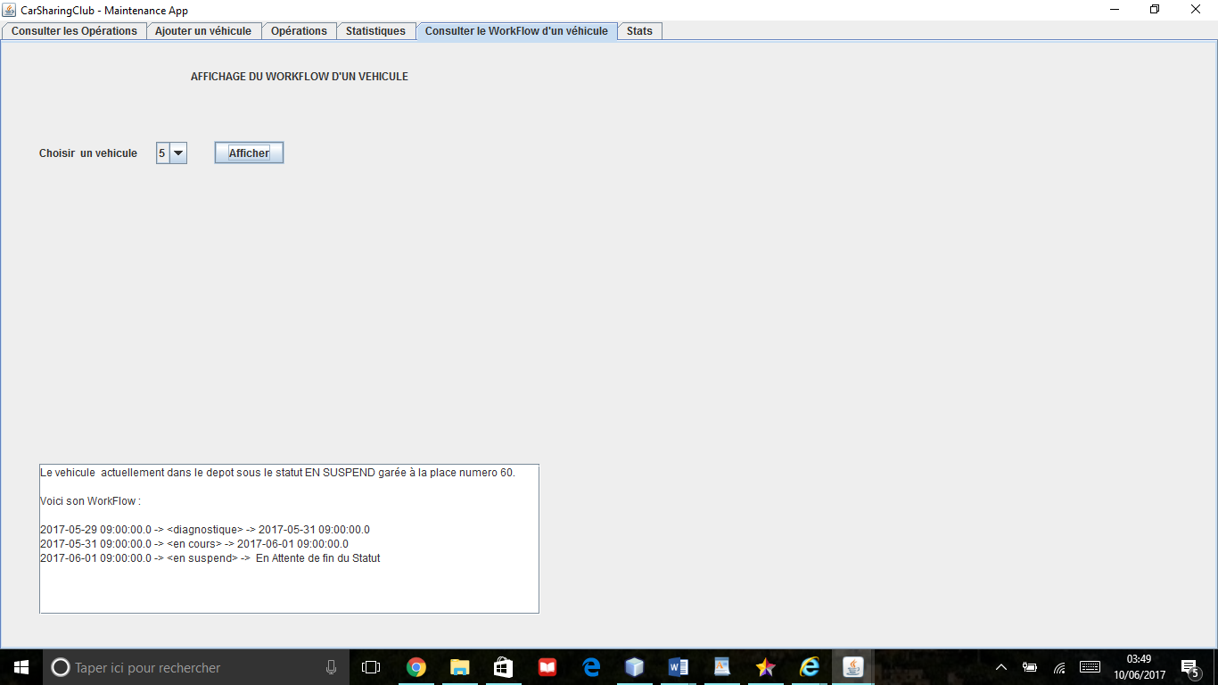

To consult the Workflow of a present vehicle in the deposit, it is enough to you to choose in the drop-down list the identifier of the car which interests you, then press the button "Afficher". You will see displaying then all the Workflow of a just vehicle below in fields empties. (See screen shot above).

1. To consult the statistics warehouseman, it is necessary to go to the tab "Statistics Warehouseman" (See screen shot below):

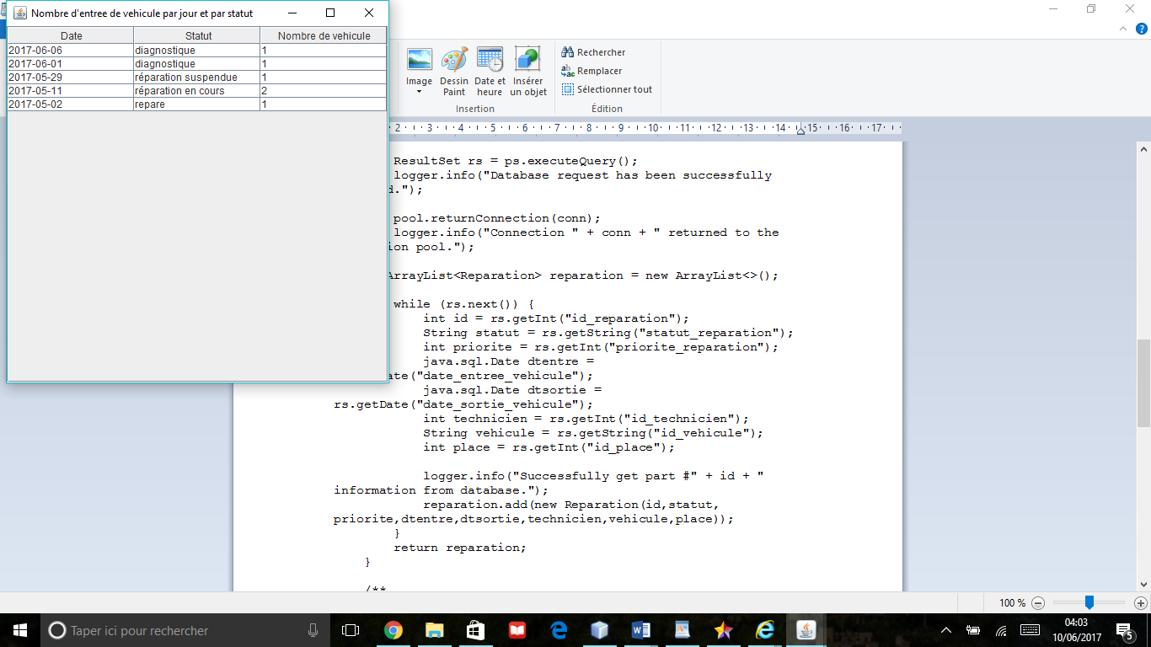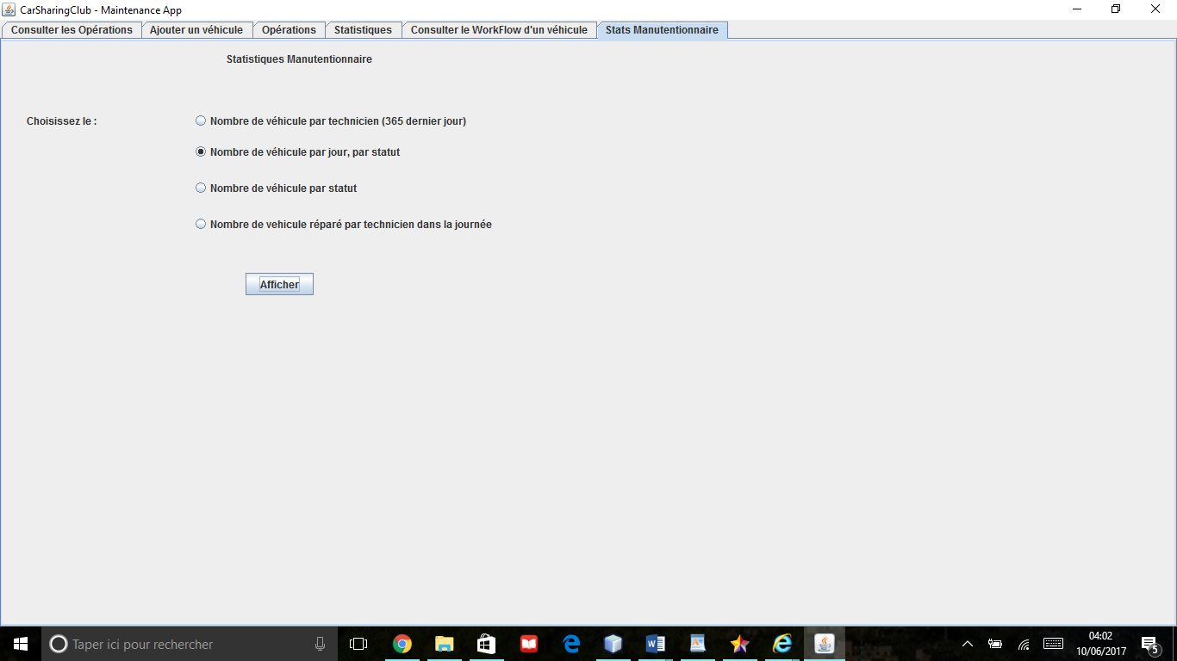

When a foreman connects it is enough to him to monitor the activity of the deposit to consult one of the predefined statistical tabs.

For it once on the tab it is enough to you to mark one of the statistics that you wish to consult, then it is necessary to press the button "Afficher" so that another window opens with the picture presenting the result of your request. (See example above).

The various statistics in the order are the following ones:

- the number of vehicle by technician (who will show for every technician the number of vehicles of which he took care on the last 365 days).

- The number of vehicle by date of in order chronological classified entrance(entry) (of the most recent in the most former(oldest)) and by status. So we can know how much vehicle by status entered during the day by looking at the first date of the picture(board).

- The number of vehicle by status at present in the deposit(warehouse).

- The number of vehicle of which a technician took care during the day. That is which(who) passed in the status repaired over 24 hours (that is during the day (or the day before)).